Does Christmas fill you with holiday cheer? Could you see yourself as head of the North Pole Post Office, helping Santa give gifts to the children, and helping children post their letters to Santa? If so, we would love your help at W5’s very Enchanted Christmas Experience.



**CORE VALUES**

The Odyssey Trust group is committed to the core ideology of BEET, Best Experience Every Time for Customers and Colleagues.

**POSITIVITY** – Smile, can do, have fun. We will always be helpful, welcoming and enthusiastic.

**INTEGRITY** – Deliver on our promise. We will be trustworthy and respectful.

**COMMITMENT** – Go above and beyond. We will go the extra mile.

**INNOVATION** – Find new ways to be better. We will always learn and improve.

**TEAMWORK** – Together we achieve more. We will work together to put you first.

**SEASONAL TEAM MEMBER**

**INFORMATION PACK**

**APPLICATIONS OPEN**

MONDAY 04.11.2024

**CLOSING DATE FOR APPLICATIONS**

THURSDAY 14.11.2024

**INTERVIEWS WILL BE HELD ON**

TUESDAY 19.11.2024

**COMMENCEMENT DATE**SATURDAY 30.11.2024

**ODYSSEY TRUST STAFF EXPECTATIONS**

* Provide outstanding customer service
* Maintain excellent working relationships with other staff and volunteers.
* Work across the Odyssey group to ensure BEET and its delivery.
* Be committed to and work in accordance with our Safeguarding, Health & Safety, Equality and other established policies and procedures.
* Be flexible undertake such other duties that may be required including working evenings, weekends and public holidays.

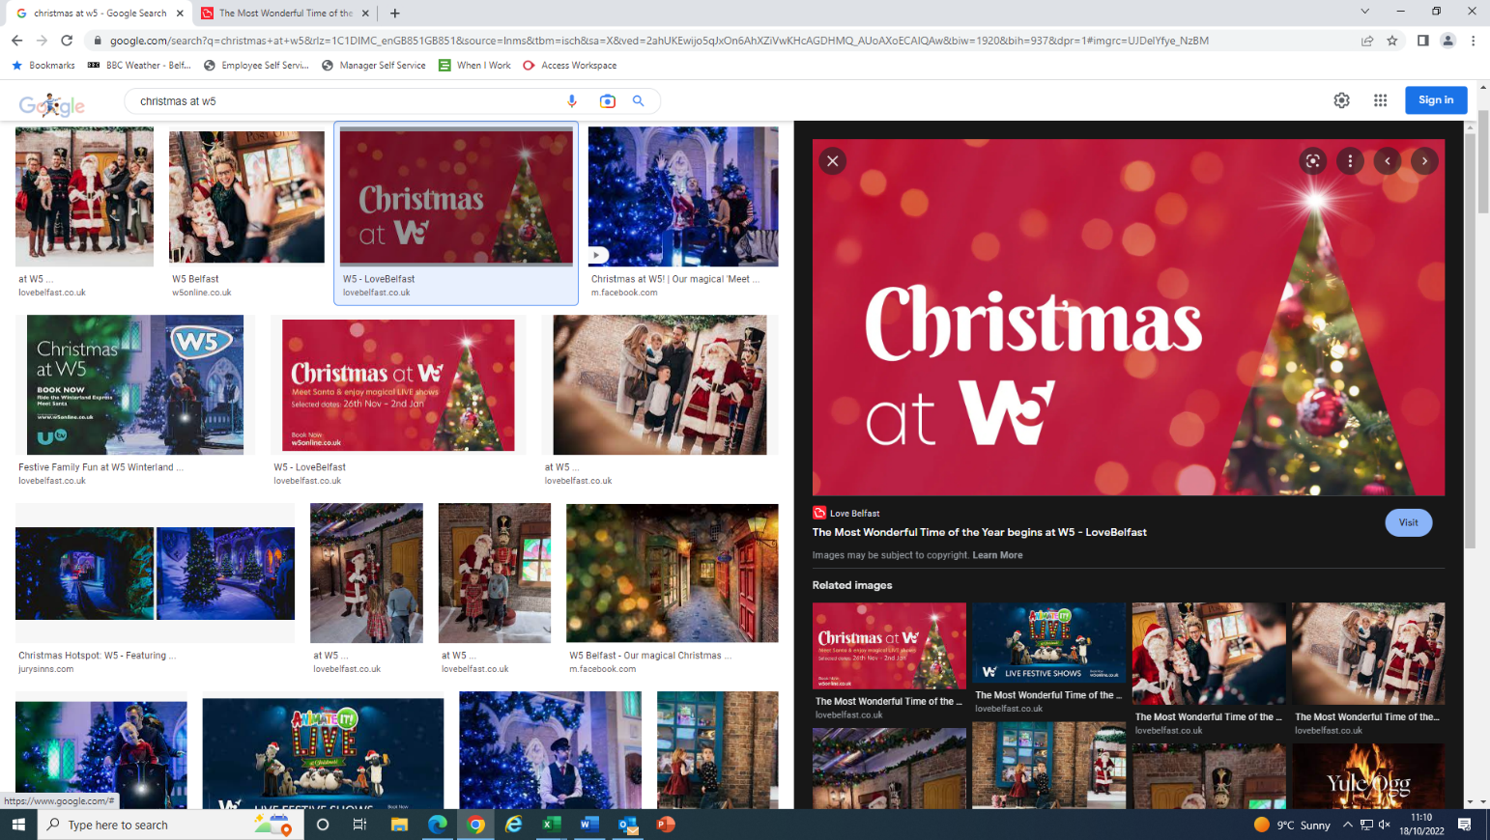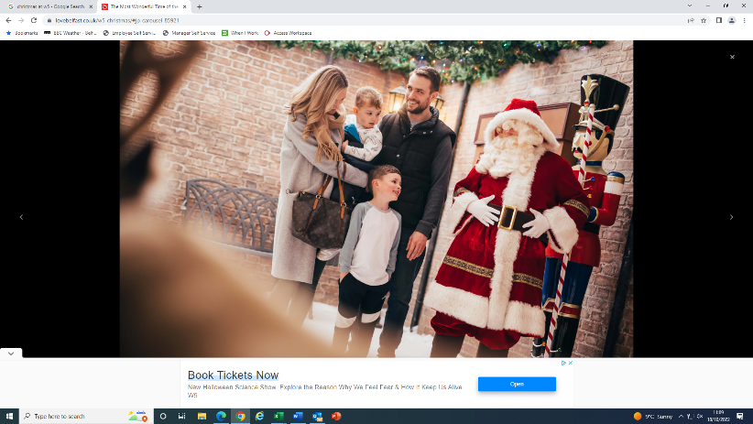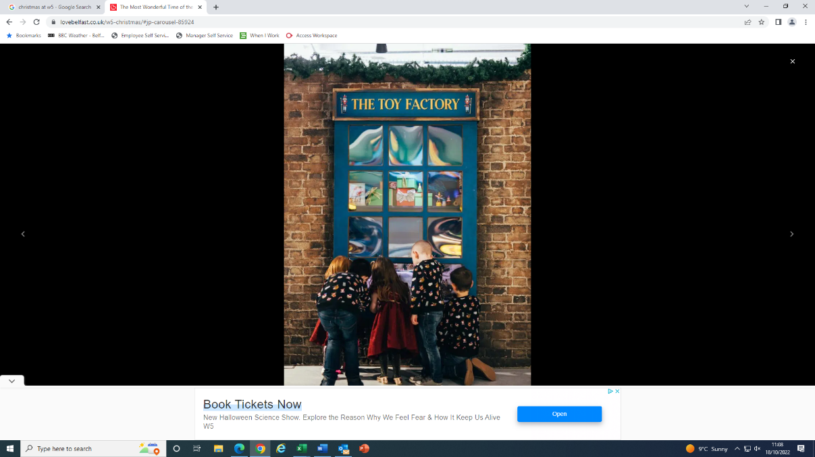

**JOB DESCRIPTION**

**Seasonal Team Member**

**SITE: W5 - Odyssey Group**

**LOCATION: Queen’s Quay, Belfast, BT3 9QQ**

**RESPONSIBLE TO: Visitor Experience Manager**

**TERMS: Seasonal Team Member (Casual contract)**

**DATE: November and December 2024/January 2025**

**SALARY: £11.50 per hour**

**OVERALL PURPOSE OF THE JOB:**

We are looking for enthusiastic and passionate individuals, who will enjoy bringing our enchanted Christmas Experience to life, interacting with children and adults alike.

**MAIN DUTIES:**

Engage with visitors throughout W5 to ensure a magical Christmas experience, undertaking the following duties: -

* **Santa Experience – ‘The Elf Academy’**

Help families create lasting memories by assisting with W5s Santa Show. Check bookings, manage the queue, help seat the families, help Santa distribute gifts and assist with the smooth running of our Santa show.

* **Papercraft Activities**

Situated in W5s North Pole Post Office, act as Postmaster and assist families in writing letters to Santa and designing Christmas cards.

* **Seasonal Snowball Fights & Penguin Curling**

Manage the queue and oversee the indoor seasonal Snowball Fight and Penguin Curling area.

* **AMAZE**

Manage admissions and capacity to “With Every Christmas Card” in our immersive multi-screen area.

* Any other duties as requested by your Line Manager.
* Hours will mostly be at the weekends and over the Christmas Holiday period.

**SELECTION CRITERIA**

**ESSENTIAL CRITERIA**

* Christmas Spirit.
* Excellent customer service skills.
* Effective communication skills and ability to engage with both families and large groups.
* Ability to work as part of a busy team.
* Ability to use initiative.
* Ability to adapt to a fast-paced environment.
* Flexibility (this role will primarily be weekends and the week leading up to Christmas)

DESIRABLE CRITERIA

* Experience in drama & performance

**ADDITIONAL INFORMATION**

* Shifts will be available between Saturday 30th November and Sunday 5th January.
* Flexible hours/days available.
* Possibility to extend the contract beyond January if business need allows.

Salary - £11.50 per hour