
DO YOU WANT TO WORK IN A FAST PACED, DYNAMIC ENVIROMENT WHERE NO TWO DAYS ARE THE SAME?
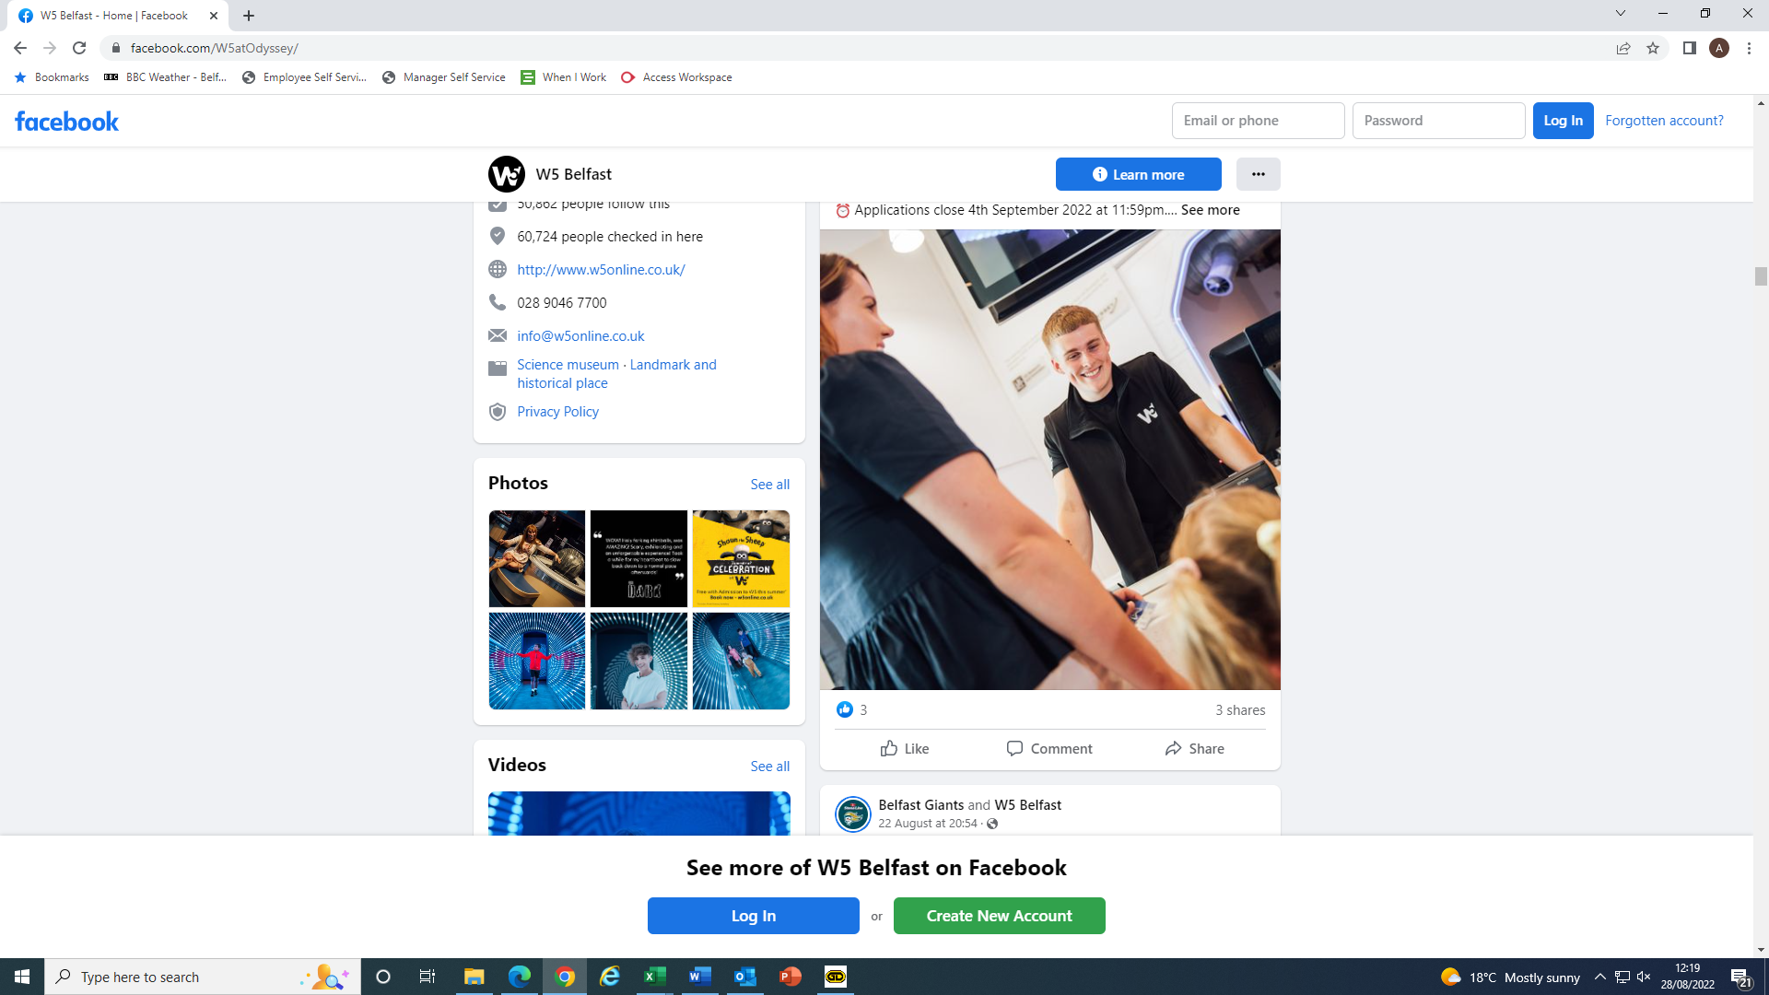
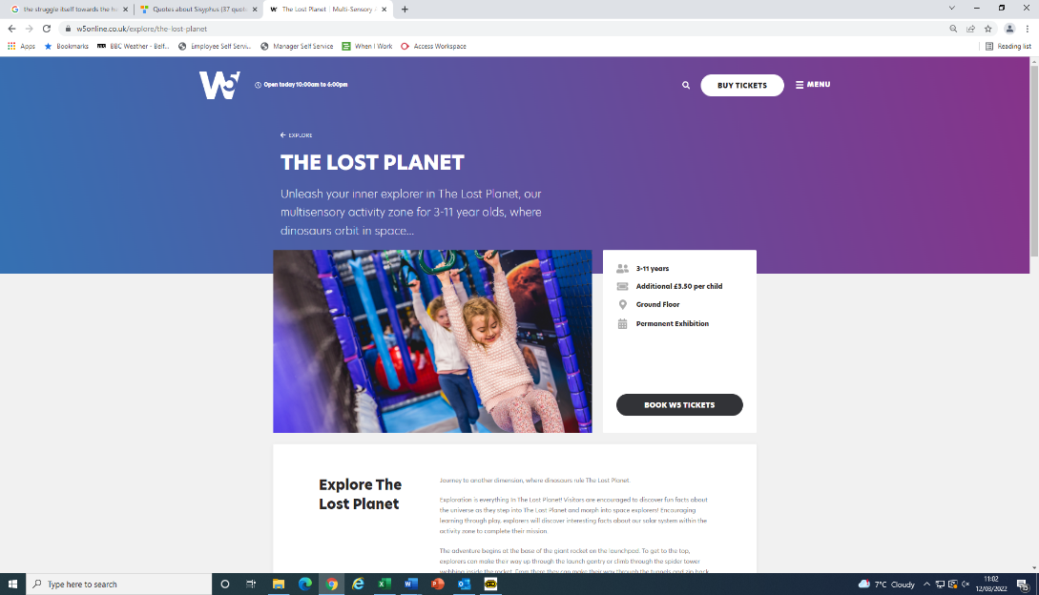
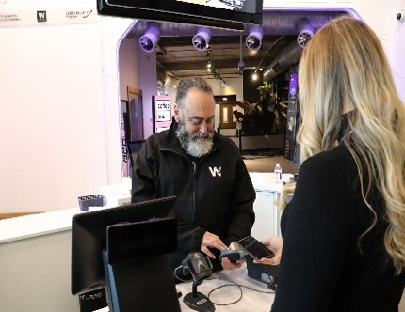

VISITOR EXPERIENCE TEAM MEMBER INFORMATION PACK

APPLICATIONS OPEN
4TH November 2024

CLOSING DATE FOR APPLICATIONS
17th November 2024

INTERVIEWS WILL BE HELD
25th November 2024

SALARY
£11.66 per hour

ODYSSEY TRUST STAFF EXPECTATIONS

- Provide outstanding customer service
- Maintain excellent working relationships with other staff and volunteers.
- Work across the Odyssey group to ensure BEET and its delivery.
- Be committed to and work in accordance with our Safeguarding, Health & Safety, Equality and other established policies and procedures.
- Be flexible undertake such other duties that may be required including working evenings, weekends and public holidays, if required.

CORE VALUES

The Odyssey Trust group is committed to the core ideology of BEET, Best Experience Every Time for Customers, Colleagues and Stakeholders.

POSITIVITY – Smile, can do, have fun. We will always be helpful, welcoming and enthusiastic.

INTEGRITY – Deliver on our promise. We will be trustworthy and respectful.

COMMITMENT – Go above and beyond. We will go the extra mile.

INNOVATION – Find new ways to be better. We will always learn and improve.

TEAMWORK – Together we achieve more. We will work together to put you first.

JOB DESCRIPTION
Visitor Experience Team Member

SITE: W5 - Odyssey Group
LOCATION: Queen’s Quay, Belfast, BT3 9QQ
RESPONSIBLE TO: Visitor Experience Manager
TERMS: Full time hours at approx. 37.5 hours per week
DATE: November 2024
OVERALL PURPOSE OF THE JOB:
This is an exciting opportunity to be part of the reimagined W5. We are looking for staff members who are excited to interact with visitors, inspiring them to engage with science and a range of shows and interactive exhibits.

MAIN DUTIES:
Engage with visitors throughout W5 undertaking the following duties: -
- Ticket Desk
Meet and Greet visitors as they arrive in W5 - visitors range from family groups, school groups and corporate clients to adult audiences attending late-night science events. Process bookings, walk-up sales, provide orientation regarding exhibition floors and daily shows/events and respond to visitor queries.
- Gift Shop
Undertake commercial duties including working on tills, stock taking, merchandising, replenishing stock on the shop floor and taking receipt of deliveries.
- Coffee Labs
Support the Food and Beverage department in the operation of the 3 Coffee Lab areas in W5.
- Lost Planet Soft Activity Zone
Manage admissions by checking tickets, provide Health and Safety orientation, supervise play, ensure rules of play are followed at all times, inspect equipment and ensure standards of cleanliness are upheld.
- Exhibition Floors
Ensure that all exhibits are operational. Direct and guide customers so they can engage with a range of science related exhibits and attend shows and events. Maximise visitor experience by demonstrating how exhibits work. Ensure Health and Safety/Safeguarding procedures are adhered to and act as a Fire Warden. Carry out cleaning and exhibit maintenance duties to ensure visitors experience a pleasant environment.
- Climbit Climbing Structure
Provide Health and Safety orientation, supervise play, ensure rules of play are followed at all times, inspect climbing structure and ensure standards of cleanliness are upheld.
- Meet and Greet Groups/Birthday Parties
Prepare for group arrival in advance of their visit. Meet and Greet groups and provide an orientation – adapting orientation based on group demographic. Facilitate visit throughout the day and follow up to ensure a quality experience.
- Corporate
Prepare for client arrival in advance of their visit including setting up meeting rooms. Meet and Greet clients and help clients as and when required.
- Any other duties as requested by your Line Manager.

SELECTION CRITERIA

ESSENTIAL CRITERIA
- Good Standard of Education.
- At least 3 month’s experience in a customer facing role in either Retail, Tourism or Hospitality.
- Appointment to these posts will require an Enhanced Disclosure Certificate from AccessNI which meets the standards required by W5.
- Flexible approach, this role will have a rota includes evenings, weekends and holiday periods.

DESIRABLE CRITERIA
Where the number of applications received warrants, W5 reserves the right to apply the following desirable criteria: -

- Cash handling experience.
- Possess a current basic food hygiene certificate [gained within the last 4 years].
- Possess a recent World Host Certificate [gained within the last 3 years]

COMPANY BENEFITS
The Odyssey Group has a range of benefits which it offers to full and part time staff:
- Free car parking
- Complimentary tickets to Belfast Giants, friends and family access to W5 and advanced ticketing to Arena events.
- 33% Discount in the W5 café & 10% discount in the W5 shop
- Contributory pension scheme, life assurance, a paid sickness benefit plus a health cash plan.
- Salary Sacrifice including pensions, holiday and cycle to work schemes

Salary - £11.66 per hour

